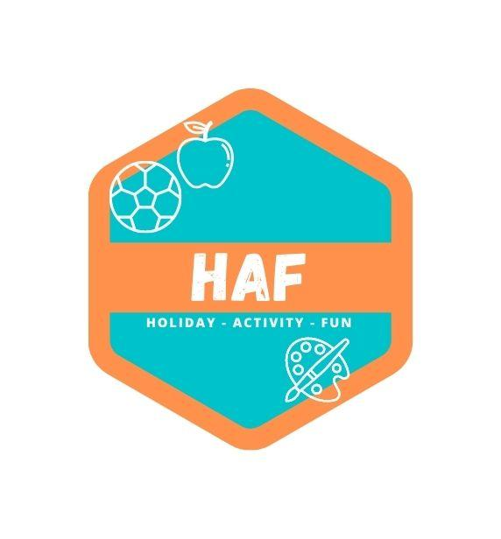

Staff Behaviour Policy
West Lancs HAF expects all members of staff to follow our Staff Behaviour Policy,
which sets clear guidance on the standards of behaviour required from our staff.
The guidance aims to encourage staff to meet the highest possible standards of conduct.
Camp staff are in a position of trust and influence as role models for the children at the camp, and as such must demonstrate behaviour that sets a good example to all users of the setting.
Camp staff also have a responsibility to maintain their reputation and the reputation of the camp, both during and outside of working hours.
Behaviour
Our staff team are ambassadors for West Lancs HAF and we expect them to conduct themselves professionally at all times. Staff should treat anyone attending the camp (children, parents/carers and visitors) courteously and with respect.
We expect staff to value all the children as individuals and to comply with the camp’s Equalities Policy at all times.
Swearing and abusive behaviour are not tolerated from anyone at the camp. If any member of staff exhibits such behaviour, they will be subject to the Endeavour Learning Trust’s disciplinary procedures.
Dress Code
Whilst working at West Lancs HAF staff will need to help to set up and pack away the setting, facilitate craft activities and engage in physical activities with the children. The clothing and footwear worn should be chosen accordingly, taking into account comfort, health and safety, and practicality. Revealing or excessively tight clothing is not acceptable.
Whilst on duty all staff should wear the approved West Lancs HAF uniform at all times.
Confidentiality and social media
Staff must not pass on any information about children attending the camp, or their parents and families, to third parties without their permission. The only exception to this rule is information sharing with specific external agencies if there is a safeguarding issue. (‘Third parties’ includes other parents, friends, other children at the camp, the press, etc.)
Posting any material relating to the camp or its users on social media sites (unless expressly permitted by the Manager) is forbidden. Any staff who breach this rule will face disciplinary action.
Use of mobile phones and cameras
Staff must keep personal mobile phones in a personal bag during working hours.
If a member of staff needs to make an urgent personal phone call, they can ask for permission from the senior member of staff.

If a member of staff has a family emergency or similar and needs to keep their mobile
phone to hand, they must obtain prior permission from the Manager or Deputy.
Staff are not permitted to smoke anywhere on the camp premises, including the
outside play areas.
Staff are not permitted to bring alcohol or illegal drugs onto the camp premises.
If a member of staff arrives at work under the influence of alcohol or drugs they will be asked to leave immediately and disciplinary action will be taken.
If a member of staff is taking prescription drugs which might affect their ability to function effectively, they must inform the Manager immediately.
Any prescribed medication needed by a staff member whilst at the camp, must be stored safely in the and out of reach and sight of the children attending the camp.
Gross misconduct
Staff will be dismissed without notice if they are found to have committed an act of gross misconduct. Examples of gross misconduct include, but are not restricted to:
• Child abuse
• Failing to comply with health and safety requirements
• Physical violence
• Ignoring a direct instruction given by the manager
• Persistent bullying, sexual or racial harassment
• Being unfit for work through alcohol or illegal drug use
• Theft, fraud or falsification of documents
• Being disqualified under the terms of the Statutory Framework for the Early Years Foundation
Stage (Section 75 of the Childcare Act 2006) or the Children’s Act 1989.
The Manager will investigate the alleged incident thoroughly before any decision to dismiss is made.

This policy was adopted by: West Lancs HAF | Date: 20/03/2023
Reviewed on: 21/06/25  To be reviewed: 21/06/26 | 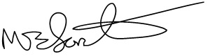  Signed: M.Forster

